How to look up articles for the word norms project:

<https://onedrive.live.com/redir?resid=E3A031EB620C394C!410&authkey=!AION14gYCFc3-Mk&ithint=folder%2c>

Go to the (table of doom) Linguistic Annotated Bibliography:

* <http://wordnorms.missouristate.edu/lab/display_small.php>
* This page includes a table of all the previously entered norms.

Check for updated information:

* When articles are entered that are published *online first*, they do not have a volume or page numbers because they haven’t been assigned yet.
* On the LAB page, search for XX-XX to find them easily (ctrl + f at the same time to bring up the search bar).
* Next to the XXs, there’s a link for the DOI (like this DOI: [10.3758/s13428-013-0442-y](http://dx.doi.org/10.3758/s13428-013-0442-y)).
* Click on the link to go to the page for the article. You can find the updated issue and volume numbers at the top (usually) of the page like this:

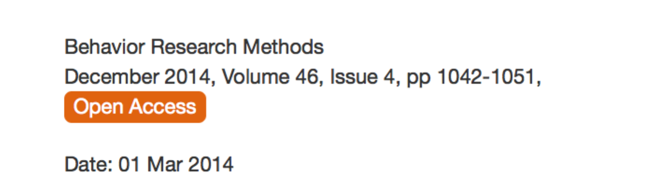

* You will be able to edit these by going here:
  + LINK COMING SOON
  + Click edit -> make changes -> click submit.

Find new articles for the database:

* In the search this journal box, try searching with the following terms:
  + Database
  + Norms
  + Corpus
  + Do each word, one at a time.
  + You will get lots of overlap between searches.
* For each search, check out the following:
  + Articles should appear to have some sort of database or be some sort of program that helps search/create linguistic data/stimuli.
  + Articles published between 2015-2016 (so be sure to sort descending after you get results, instead of most relevant).
  + If you aren’t sure, include it – I can figure out which ones to exclude pretty fast.
  + Check if they are already in the LAB – search page with all the articles linked above.
* If you find an article that seems to work and is not already in our database, download the PDF. You can bring those on a flash drive to the lab, download them to a folder in the lab OneDrive > Projects > Table of Doom > 0 deal with this.
  + If you are on campus doing the search, we should have access to all the articles in the journal. If not, just email the citation (article authors, name or even website link) to me.
* Places to search:
  + Behavior Research Methods: <http://link.springer.com/journal/13428>
  + Google scholar: <http://scholar.google.com>
  + PLoS One: <http://www.plosone.org>
    - For google scholar and plos one add the word *linguistic* to the search term for each one or you will get all kinds of random stuff.
  + PsycInfo: <http://library.missouristate.edu>
    - Click on articles and databases.
    - Click P.
    - Click PsycINFO.
    - Search!